Section 11.1: Simplifying Radical Expressions

SOLs: The student will
A.3 xxxxx

Objectives: Students will be able to:
Simplify radical expressions using the Product Property of Square Roots
Simplify radical expressions using the Quotient Property of Square Roots

Vocabulary:
Radical Expression –
Radicand –
Rationalizing the denominator –
Conjugate –

Key Concept:

Examples:
- Simplify the following:
A.
B.
- Simplify
- Simplify
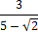
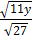
- Simplify the following:
A.
B.
C.

Concept Summary:
A radical expression is in simplest form when no radicands have perfect square factors other than 1, no radicands contain fractions, and no radicals appear in the denominator of a fraction

Homework: pg
Section 11.2: Operations with Radical Expressions

SOLs: The student will
A.3 xxxxx

Objectives: Students will be able to:
Add and subtract radical expressions
Multiply radical expressions

Vocabulary: none new

Key Concept:

Examples:

- Simplify the following:
A.
B.
- Simplify
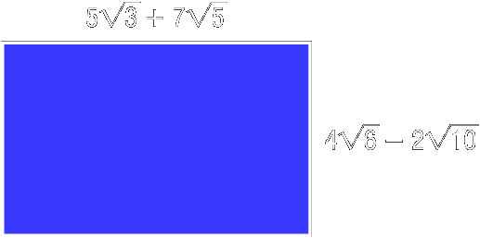
- Geometry: Find the area of a rectangle

Concept Summary:
Radical expressions with like radicands can be added or subtracted
Use the FOIL method to multiply radical expressions

Homework: pg
Section 11.3: Radical Equations

SOLs: The student will
A.1 xxxxx

Objectives: Students will be able to:
Solve radical equations
Solve radical equations with extraneous solutions

Vocabulary:
Radical equation –
Extraneous solution –

Key Concept:

Examples:

- Free-Fall Height: An object was dropped from an unknown height and reaches the ground in 5 seconds. From what height was it dropped?
- Solve for x:
- Solve for y:

Concept Summary:
Solve radical equations by isolating the radical on one side of the equation. Square each side of the equation to eliminate the radical.

Homework: pg
Section 11.4: Angle Measure

SOLs: The student will
A.1 xxxxx

Objectives: Students will be able to:
Solve problems by using the Pythagorean Theorem
Determine whether a triangle is a right triangle

Vocabulary:
hypotenuse –
legs –
Pythagorean triple –
Corollary –

Key Concept:

Examples:

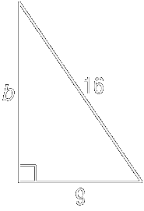
- Find the length of the hypotenuse of a right triangle if a = 18 and b = 24.
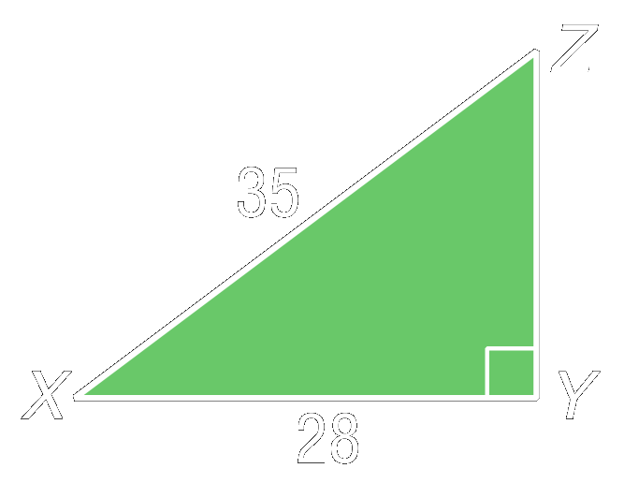
- Find the length of the missing side
- What is the area of triangle XYZ?
A. 94 units²
B. 128 units²
C. 294 units²
D. 588 units²
- Determine whether these side measures form a right triangle.
A. 7, 12, 15
B. 27, 36, 45

Concept Summary:
If a and b are the measure of the legs of a right triangle and c is the measure of the hypotenuse, then c² = a² + b²
If a and b are the measure of the shorter sides of a triangle, c is the measure of the longest side, and c² = a² + b², then the triangle is a right triangle

Homework: pg
Section 11.5: Distance Formula

SOLs: The student will
A.1

Objectives: Students will be able to:
Find the distance between two points on the coordinate plane
Find a point that is a given distance from a second point in a plane

Vocabulary:
None new

Key Concept:

Examples:

- Find the distance between the points (1, 2) and (-3, 0)
- Biathlon: Julianne is sighting her rifle for an upcoming biathlon competition. Her first shot is 2 inches to the right and 7 inches below the bull’s-eye. What is the distance between the bull’s-eye and where her first shot hit the target?
- Find the value of a if the distance between the points at (2, –1) and (a, –4) is 5 units.

Concept Summary:
- The distance d between any two points with coordinates (x₁, y₁) and (x₂, y₂) is given by
d = √(x₂ – x₁)² + (y₂ – y₁)²
- It is an application of the Pythagorean theorem

Homework: pg
Section 11.6: Similar Triangles

SOLs: The student will
A.3

Objectives: Students will be able to:
Determine whether two triangles are similar
Find the unknown measures of sides of two similar triangles

Vocabulary:
Similar triangles –

Key Concept:

Examples:
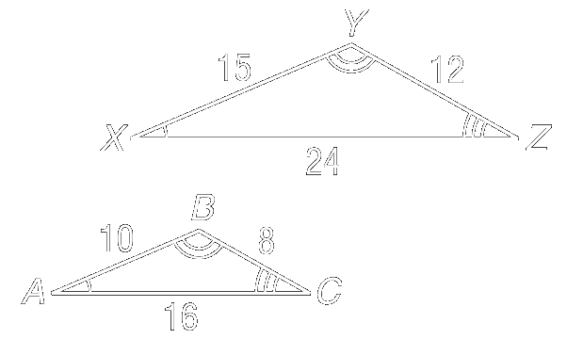
- Determine whether the pair of triangles is similar. Justify your answer.
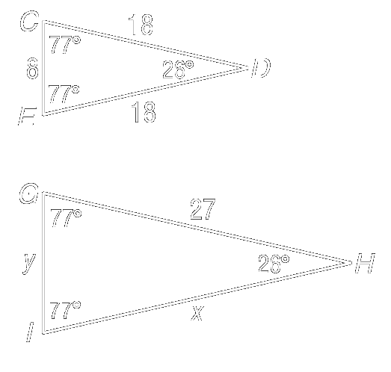
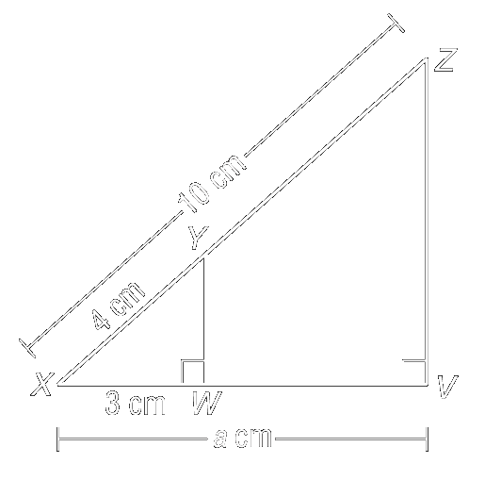
- Find the missing measures if the pair of triangles is similar
A. .
B. Find the missing measures if the pair of triangles is similar.
- Shadows: Richard is standing next to the General Sherman Giant Sequoia three in Sequoia National Park. The shadow of the tree is 22.5 meters, and Richard’s shadow is 53.6 centimeters. If Richard’s height is 2 meters, how tall is the tree?

Concept Summary:
Similar triangles have congruent corresponding angles and proportional corresponding sides.

Homework: pg

Section 11.7: Trigonometric Ratios

SOLs: The student will
A.3

Objectives: Students will be able to:
Define the sine, cosine, and tangent ratios
Use trigonometric ratios to solve right triangles

Vocabulary:
Trigonometric ratios –
sine –
cosine –
tangent –
angle of elevation –
angle of depression –

Key Concept:
Examples:

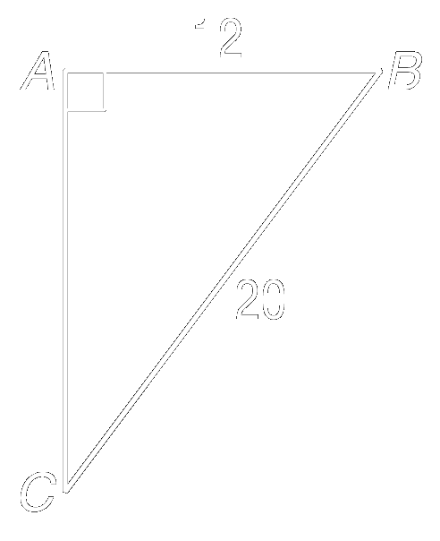
- Find the sine, cosine, and tangent of each acute angle of ∆DEF. Round to the nearest ten-thousandth.
- Find cos 65° to the nearest ten thousandth.
- Find the measure of ∠B to the nearest degree.
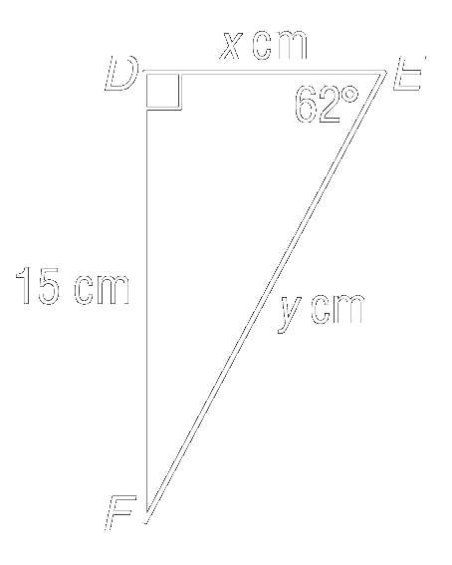
- Find all of the missing measures in ∆DEF

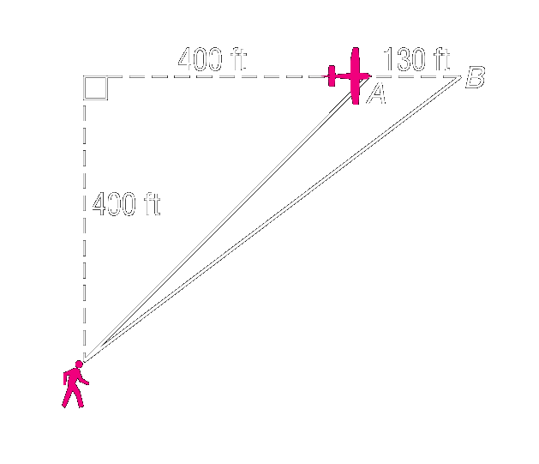
- Indirect Measurement: In the diagram, Barone is flying his model airplane 400 feet above him. An angle of depression is formed by a horizontal line of sight and a line of sight below it. Find the angles of depression at points A and B to the nearest degree.

Concept Summary:
Similar triangles have congruent corresponding angles and proportional corresponding sides.

Homework: pg

